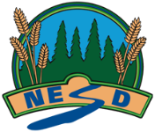
North East School Division
Unpacking Outcomes
Module 34B: Agricultural Business (Optional)
Unpacking the Outcome
Examine --> business ownership

Outcome (circle the verb and underline the qualifiers)
Examine business ownership as applied to agricultural industry.

KNOW | UNDERSTAND | BE ABLE TO DO
Vocabulary:  Forms of business ownership:  - sole proprietorship, corporation, franchise, partnership, cooperative model (*1) | That | - Recognize forms of business ownership and discuss the applications to agricultural settings.(*1)  - Discuss the benefits of different forms (e.g., sole proprietorship, corporation, partnership) of business ownership as applied to agriculture.  - Differentiate between cash and accrual accounting systems used within agriculture.
ESSENTIAL QUESTIONS

